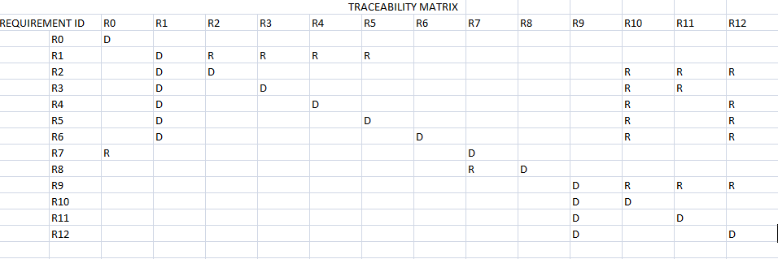
REQUIREMENTS ID REQUIREMENT NAME
R0 visit website
R1 : login
R2: placement news
R3: previous question papers and aptitude test
R4: professors contacts
R5: alumni contacts
R6: student activities and achievements
R7: develops website
R8: update website
R9: manage files
R10: upload files
R11: delete files
R12: add content

